**PASS BY REFERENCE**

Lab Exercise # 5

Submitted by:**Sumalinog, Ethan Chav Isaac P.**

Submitted to:**Mr. Nasvin Del Rosario**

**Challenge:**

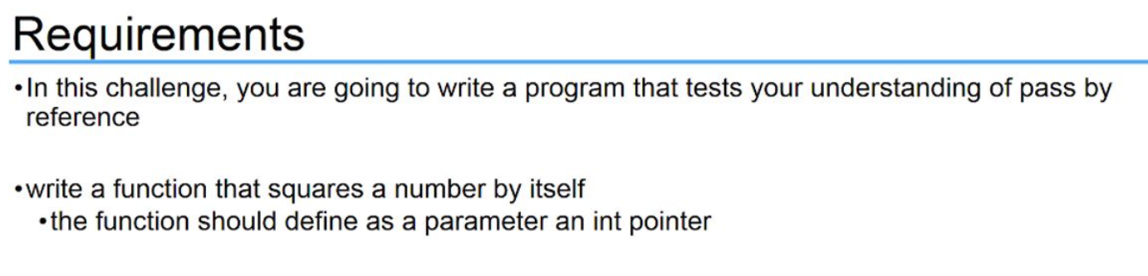

**Solution:**

I start with the main function and declared variable ‘number’. I then use a *scanf* to get input from the user and put its value to the address of the variable number. I directly used a *printf* function with have the argument that calls the function *square* that squares the value that we gave to the variable *number*.

In the function *square*, I declare an integer pointer *x* as the parameter. This accepts integer values such as input from the variable *number*. Afterwards, I declare another integer variable *sqr* that gets multiplies the dereferenced value of the pointer *x*, which is the value from the variable *number*, to itself – squaring it. It then returns the value and the *printf* does the rest of printing out the value.

**Code:**

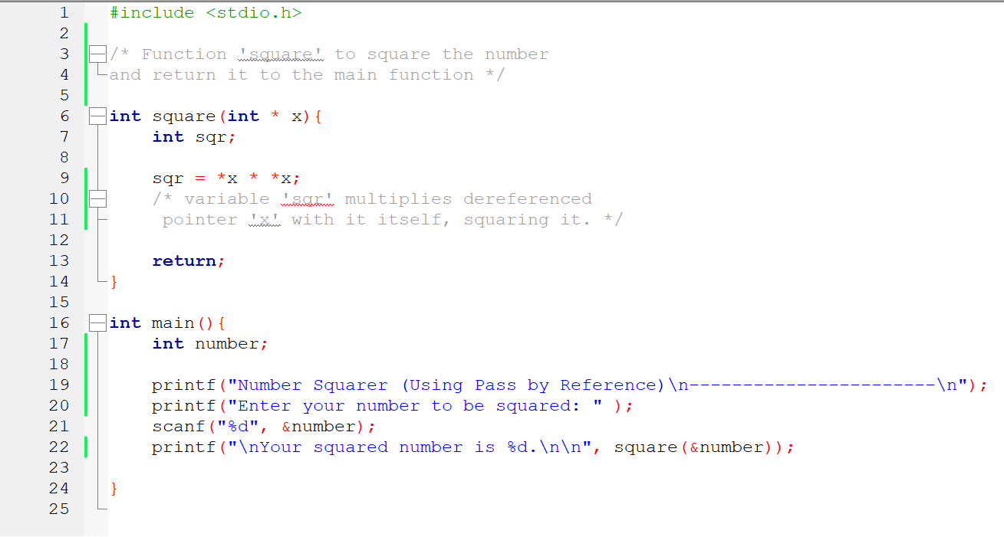

**Output:**

